all.php (例子: static SQL statement)

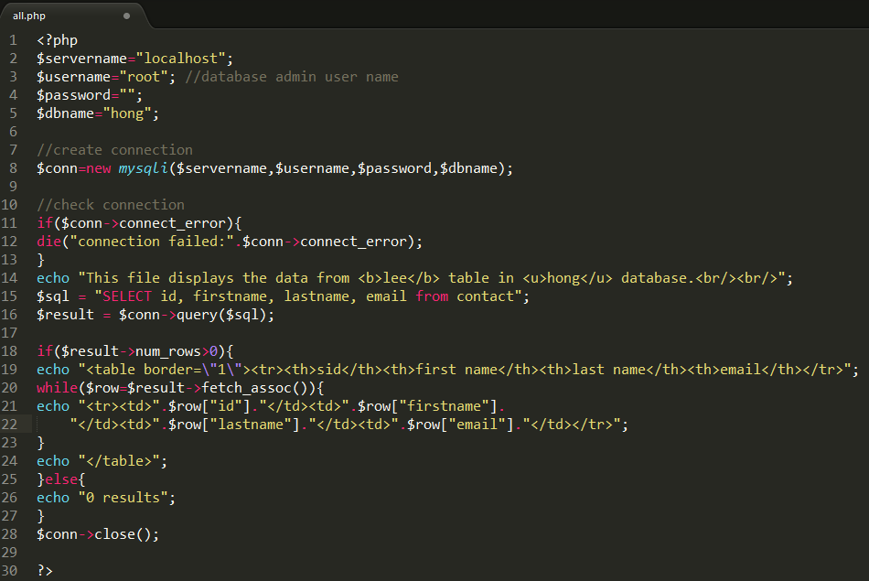

sid.php (例子: dynamic SQL statement)

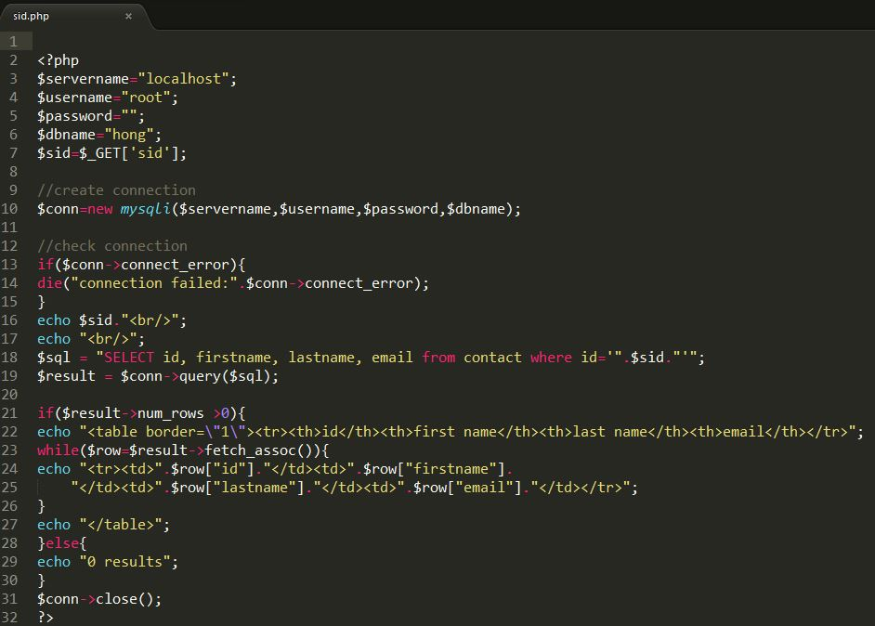

When run the query in web. type: localhost:8888/sid.php?sid=2 ‘ or ‘1’ = ‘ 1